Kid Nation
Youth
Hey Teens! Are you tired of wondering what your purpose is in life? We can help!
We are Chris & Taylor Hamby and our main goal as Christ Nation Youth Leaders is to bring every soul we encounter to Christ and help them find their purpose! In doing so, we will teach Bible based lessons to help them learn all about Jesus and the relation of stories in The Bible, to the world we live in now. We will accomplish this by reading scripture from The Bible, praying, playing games, watching video clips or movies, incentives and group discussion. We will prepare our teens for the REAL WORLD as Christian adults! We also expect our teens to act as Jesus by being servants and showing AGAPE LOVE, the love of Christ, by going outside of the four walls to interact with others by praying, feeding the homeless and other small acts of kindness. We also like going out to do different activities, fundraisers and weekend getaways to youth conferences!
Come fulfill your purpose with us!

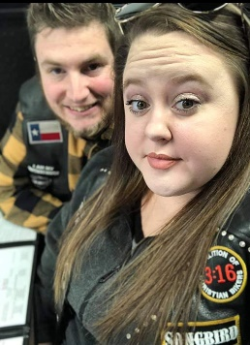
Songbird aka Tay Tay & Big Texas

Christ Nation
Ministries

SOUL SISTERS
Women’s Ministry

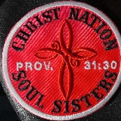
Men’s Ministry

DONATION OPTIONS
$ChristNation
@ChristNation314
@ChristNation314Ministries

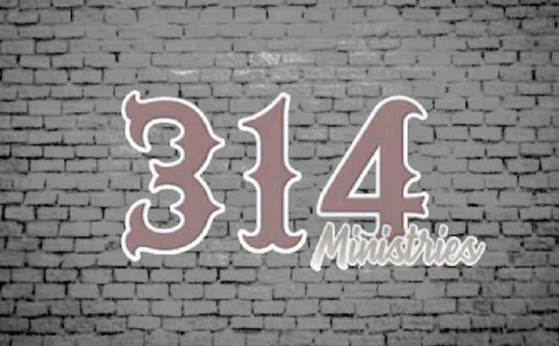
Christ Nation
Ministries
Where You can find out more about us:
@_christnation314
cn.314
christ_nation_314
Christ Nation314
www.christnation314.com

Founder & Co-Founder’s Vision
In January 2020, the Lord woke me up during the night and impressed in my Spirit that He wanted me to start a motorcycle ministry. I thought maybe I was dreaming and went back to sleep. A little while later the same thing happened. The Lord woke me up and told me he wanted me to begin a motorcycle ministry. All the next day, I just couldn’t get away from the thought of starting a motorcycle ministry. I thought, this is crazy because I do not own a motorcycle and haven’t even ridden a motorcycle in since I was young. But I told the Lord, if this truly is you Lord, I am going to post my chop top Volkswagen on Facebook and see if anyone wants to trade for a Harley (I always wanted a Harley). Within 30 minutes or so a friend on my Facebook page said, Hey, come check out what I have. I went to the guy’s home and he had several motorcycles and asked me which one I wanted. He said he had always wanted a Volkswagen and I had always wanted a Harley, so we traded just that easy! It was a God thing!! I told the Lord, okay, now you have my attention and with this the Christ Nation Ministry and logo was birthed. We began “rolling church” where we drove motorcycles to a different church each Sunday. My wife said, I love learning the Word and love fellowship with other believers. She had stated she was going prepare a lesson and see if anyone in the Ministry was interested in coming to our home for Bible Study on Wednesday night. The first night we had approximately 20-25 people come to Bible Study. During this time, I acquired my Pastoral License. (I have known for a while I was called to preach the gospel of Jesus). During this time several of our members said, we should have our own Sunday service. We had our very first service in Chimney Rock, NC on October 18, 2020. From then we continued having Wednesday night Bible Study in our home every Wednesday. We have two of our Christ Nation Members, P.P and Mouse (Paul and Michele Palmer) who opened up their home to us and allowed us to begin having Sunday Services in their home. Our first broadcasted (live) service was November 29th, 2020. We are so excited about what God is doing and seeing the lost transformed into their new life with Jesus Christ. We are so humbled that God chose us to be a part of this Journey.

Dunk & “G”

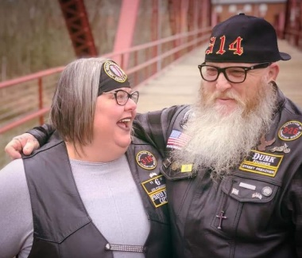

Kid Nation
The Tribe Vison
Our vision as Children’s Leaders for The Tribe is to show children the love of God. We want to teach them about Jesus and how he loves us. We want to accomplish this by teaching them through Bible stories, music, fun, games and crafts, but most importantly by loving them and teaching them to love like Jesus. We’ve heard it said that it takes a village to raise a child. We want to be part of your village to help train your children in the Word of God and the ways they should go.

Chatter & Ranna
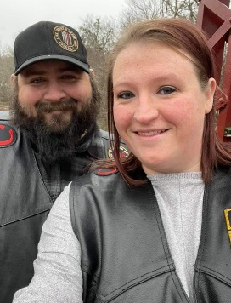
www.christnation314.com

