OUR LEADERS
Chris and Ashley Hamby
Hey Teens! Are you tired of wondering what your purpose is in life? We can help!
We are Chris & Taylor Hamby and our main goal as Christ Nation Youth Leaders is to bring every soul we encounter to Christ and help them find their purpose! In doing so, we will teach Bible based lessons to help them learn all about Jesus and the relation of stories in The Bible, to the world we live in now. We will accomplish this by reading scripture from The Bible, praying, playing games, watching video clips or movies, incentives and group discussion. We will prepare our teens for the REAL WORLD as Christian adults! We also expect our teens to act as Jesus by being servants and showing AGAPE LOVE, the love of Christ, by going outside of the four walls to interact with others by praying, feeding the homeless and other small acts of kindness. We also like going out to do different activities, fundraisers and weekend getaways to youth conferences! Come fulfill your purpose with us!
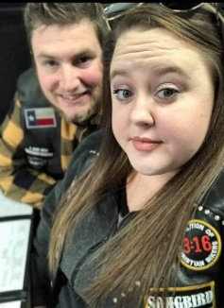
Songbird aka Tay Tay & Big Texas

Christ Nation
Ministries

SOUL SISTERS
Women’s Ministry

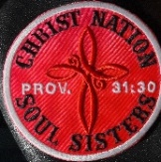
Men’s Ministry

DONATION OPTIONS
$ChristNation
@ChristNation314
@ChristNation314Ministries

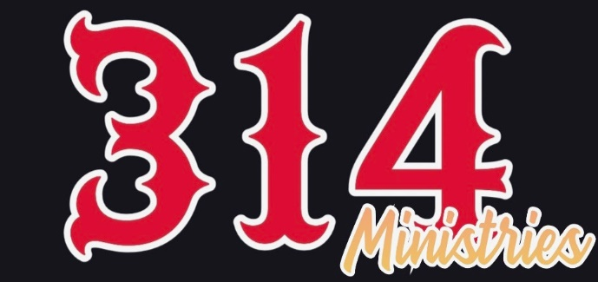
Christ Nation 314
Ministries
Where You can find out more about us:
@_christnation314
cn.314
christ_nation_314
Christ Nation314
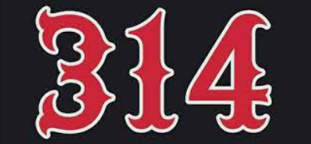 www.christnation314.com

Founder & Co-Founder’s Vision
Chris and Angie Duncan
In January 2020, the Lord woke me up during the night and impressed in my Spirit that He wanted me to start a motorcycle ministry. I thought maybe I was dreaming and went back to sleep. A little while later the same thing happened. The Lord woke me up and told me he wanted me to begin a motorcycle ministry. All the next day, I just couldn’t get away from the thought of starting a motorcycle ministry. I thought, this is crazy because I do not own a motorcycle and haven’t even ridden a motorcycle in since I was young. But I told the Lord, if this truly is you Lord, I am going to post my chop top Volkswagen on Facebook and see if anyone wants to trade for a Harley (I always wanted a Harley). Within 30 minutes or so, a friend on my Facebook page said, Hey, come check out what I have. I went to the guy’s home and he had several motorcycles and asked me which one I wanted. He said he had always wanted a Volkswagen and I had always wanted a Harley, so we traded just that easy! It was a God thing!! I told the Lord, okay, now you have my attention and with this the Christ Nation Ministry and logo was birthed. We began “rolling church” where we drove motorcycles to a different church each Sunday. My wife said, I love learning the Word and love fellowship with other believers. She had stated she was going prepare a lesson and see if anyone in the Ministry was interested in coming to our home for Bible Study on Wednesday night. The first night we had approximately 20-25 people come
to Bible Study. During this time, I acquired my Pastoral License. (I have known for a while I was called to preach the gospel of Jesus). During this time several of our members said, we should have our own Sunday service. We had our very first service in Chimney Rock, NC on October 18, 2020. From then we continued having Wednesday night Bible Study in our home every Wednesday. The Holy Spirit has since led us to our home church, New Jerusalem Baptist Church in Greer. We do continue on occasion with rolling church that we call Nation Invasion. We are so excited about what God is doing. We love to see the lost transformed into their new life with Jesus Christ. Our vision is to be used by Jesus and to be led by the Holy Spirit as we transform the lost into salvation, then into great Disciples. We are so humbled that God chose us to be a part of this Journey. We have sold out 100% to Jesus Christ and will do whatever it takes

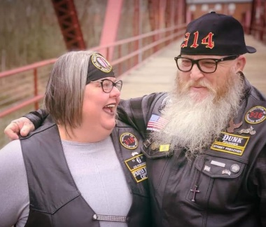
Dunk & “G”
OUR LEADERS
Todd and Marianda Craine
I am humbled by the call to serve 314 ministries as Chaplain. Had you told me a few years ago that I would be a part of a motorcycle ministry I would have probably laughed it off, but God’s plans are not our plans. To start, I had never been a motorcycle rider before I met Christ Nation M.M. I had strayed away from God and this group of misfits took me and loved me for me. They showed me the love of God and showed me that God had not abandoned me. I had grown up in church and was called to ministry at a young age but I ran from the call of God. Since I’ve been with the ministry my wife and I have grown more in God that I have ever before. I have started walking in the call God has placed on my life. Being a part of this ministry inspired me to start attending Liberty University to get a B.S. in Biblical studies and Theology to learn more about God and ministering to people. My hope as Chaplain for 314 Ministries is to find people that are hurting, lost, and in need of a savior to show the same love that brought me back to a loving God. My prayer is that we as a ministry make an impact on the lives of as many people as we can a grow the kingdom of God.
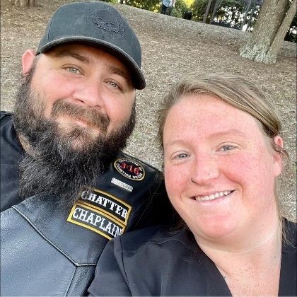
Aka Chatter and Ranna

